# Eksamen 2022

Af Jesper Graungaard Bertelsen, AU-ID: au689481

Indholdsfortegnelse

Eksamen 2022 1

Teori 3

Fourier serie representation: 3

Frekvenser og deres representation 3

Periodisk: 3

Memoryless 4

Kausult 4

Stabilitet 4

Time variance: 5

Linearitet 5

Opgave 1 7

a. Determine whether or not each of the following signals is periodic. Justify all your answers with necessary calculations. If it is periodic, determine the fundamental period. 7

b. Determine whether or not the following systems are memoryless, causal, stable, time-invariant, and/or linear. 9

Memoryless 9

Causal 9

Stability: 10

Time invariance: 10

Linearity 11

Opgave 2. Fourier representation 12

Opgave 3: LTI system beskrevet ud fra differentialligning 17

a. Determine the frequency response of the system. 17

b. Sketch the bode plot of the system. 18

c. Determine the output when the input is: 18

Opgave 4. Discrete time LTI system with impulse response. 20

a. Consider a discrete time LTI system with the impulse response and inputs signal… 20

b. Consider a CTLTI system with the impulse response 21

c. 23

Opgave 3 29

Opgave 4 29

## Teori

### Fourier serie representation:

#### Frekvenser og deres representation

:

Derfor kan jeg splitte den exponentielle funktion op i:



Kun reele dele tilbage.

### Periodisk:

For

Gælder der, at funktionen kun er periodisk, hvis  
, ( Altså ikke noget med pi i ).

### Memoryless

Hvis systemet hverken ser på tidligere eller fremtidlige værdier, men kun ser øjebliksbilledet

### Kausult

Hvis for en hvilken som helst tid før start, at outputtet er 0, så er systemet kausult.

### Stabilitet

Hvis der for hver tid t gælder, at

Og der da gælder at   
Så er systemet stabilt.

Eks.   
   
Grænsen lægger jeg til:   
Da vil   
Ikke være endelig for alle t’er, da t kan gå mod uendelig, og outputtet vil derfor også gå mod uendelig. Da vil systemet ikke være stabilt.

Eks.  
   
Grænsen lægger jeg til   
Og da vil

Systemets output kan da beskrives som endeligt for alle t og dermed er systemet stabilt.

### Time variance:

<https://en.wikipedia.org/wiki/Time-invariant_system>

Systemet er tids invariant hvis et delay i inputtet er det samme som et delay i outputtet.

Input delay:  
   
Output delay:   
   
Derfor er systemet tids invariant, da

Tids variant:  
   
Input delay:   
   
Output delay:

Da gælder der at systemet da er tids variant.

### Linearitet

Lidt samme smøre som for tids invarians:   
Hvis der gælder, at en ændring i amplitude foretaget af en faktor til inputtet resulterer i den samme faktor på outputtet, så er systemet lineært.

En faktor på inputtet:   
   
En faktor på outputtet:   
   
Da så er systemet lineært.

Ikke lineært  
   
En ændring i inputtet:   
   
Samme ændring nu på outputtet:   
   
da så er systemet ikke lineært.

## Opgave 1

### Determine whether or not each of the following signals is periodic. Justify all your answers with necessary calculations. If it is periodic, determine the fundamental period.

(Computer plots are neither needed nor accepted as an answer.)

For peridocity the function must fullfill that:

,

Where T is the fundamental period.

1. is periodic as it’s a regular cos only with amplitude, frequency and phase.

A cosx has a period of .   
   
.   
Thus, T is just a multiple of this period added to the function.



1. is a more dificult function to find the periodicity for.

But I can’t use trigonometric identities to describe it in another way.

Which also follows the formula of a standard cos function, just now with a dc element.



It’s periodic when

Thus this function is periodic with a periodicity of

1. might not be a periodic function as one frequency is of rational numbers and one irrational.

Researching it, it then actually shows, that this is a non-periodic function.   
If it wouldn’t have been, then

Then the lowest common denominator will be the fundamental frequency.   
For this one, they already have common denominator, but as one of them is irrational, and one rational, this doesn’t mean, the period is . Otherwise, it would have been.



1. , I can already tell, that this function is periodic as this is the imaginary circle function. It has it’s period at

But to further show this, I can’t expand the function.   
   
as can be seen, they have the same frequency but different amplitude and phase, but these to doesn’t matter.   
What matters is that the trigonometric functions are periodic in 2pi.

.





=========================================================================



========================================================================

Efter fortolkning   
Reglen for hvornår summen af to funktioner er periodisk hedder, at forholdet   
 skal være rationelt for at summen af funktionerne er periodisk.

For mit tilfælde i 3’eren, så havde jeg , og da er irrationel, så gælder kriteriet ikke her.

### Determine whether or not the following systems are memoryless, causal, stable, time-invariant, and/or linear.

#### Memoryless

As this function takes not only current but future values, then this system is not memoryless.

This function with a reference at n = 0, takes in either a present value or a future value. As its not only a view into the present input, the system is said to be with memory.

#### Causal

Causality comes from an output being 0 for every t < 0. This can be translated into a description of a system that only response to present or past values.

This system tries to predict the future inputs and is therefore regarded as a non-causal system.

This system sends through a possible prediction for its output, therefore making this system non-causal.

#### Stability:

If the input is bounded to a finite number for any t, and the output then is bounded to a finite number for any of these inputs, then the system is stable.

Inputs:

Then the system can be described within a finite boundary for all t, which makes this system stable.

For this the boundary will be the same for either possible values, and as it’s just the input, then

Which is bounded within finite values, therefore the system is stable.

#### Time invariance:

If a delay at the inputs is equal to a delay at the outputs, then the system is time-invariant.

Since then the system is time invariant.

Since then the system is time invariant.

#### Linearity

Now for the last property. This tells if a factor times the inputs is the same as the output being timed that same fraction.

Since then this system is not linear.

As then the system is linear.

The properties are then

===========================================================================

|  |  |  |  |  |  |
| --- | --- | --- | --- | --- | --- |
|  | Memoryless | causal | Stable | TI | Linear |
|  | No | No | Yes | Yes | No |
|  | No | No | Yes | Yes | Yes |

===========================================================================

## Opgave 2. Fourier representation

Determine the Fourier series representation of the following signal with period T = 4.

I found the analysis equation, which I will use to find  
 the coefficients of this system.

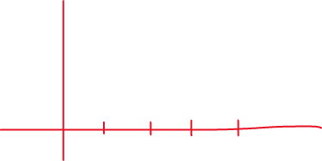



The integral I can split into the two non zero parts.

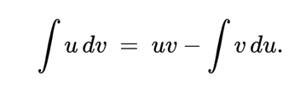The first one needs integration by parts.

I solved it myself, to check the result of wolfram, and our results matched.

Now the second integral is easy.

I then find:

Now let me check the exponential functions for zeros and values.

I can then describe the exponential function in terms of even or odd numbers.

Now for my next exponential.



Let me simplify the equation, such that

So let me describe the coefficients for odd % 4 = 1. [1, 5, 9, 13, 17, …]

Now for real / imaginary:

Figure 1: Python brute force results

They are equal. Now for the next odd.

Common denominator:

Gathering real / imaginary parts:

Figure 2: Brute force in python

They are equal.

Now for the even % 4 = 0:

Parts go out, im left with:

So this one is purely imaginary:

Figure 3: Brute force in python

They are the same.   
Now for the final one, the even % 4 = 2:

Common denominator

They are equal.

Figure 4: Python brute force

Now I can describe ak purely by:   
If I had first realized, that the even term also depended on is divisible, then I would have made the functions in chronological order, but when I realized, I had already done some work.

===========================================================================

Which are the coefficients that can be used to recreate the signal

===========================================================================

I tried recreating this plot, but it didn’t seem like it could handle the large transistion that this signal has… not with the amount of time points ( 2000 ) and amount of coefficients ( 480 ) I had. Even though this required calculation of xt 2000 * 480 = 960.000 times!   
I was worried for my pc.

## Opgave 3: LTI system beskrevet ud fra differentialligning

A linear time-invariant ( LTI ) system is described by the following differential equation

Where x represent the input signal and y represent the output signal.

### Determine the frequency response of the system.

I chose to use laplace transform to describe this and set every initial condition to zero, thus making a transform of a differential

Laplace on the system.

As

=================  
   
=================

### Et billede, der indeholder tekst, diagram, linje/række, Kurve Automatisk genereret beskrivelseSketch the bode plot of the system.

Sketched in terms of from

### Determine the output when the input is:

But also

And it’s that approach I will be doing.

Using sympy just to make sure, that it isn’t to different than just

It wasn’t.

For follows that the ROC is when   
 F  
For this one, as sympy returned for it’s second output, the real part must be larger than   
 or in this case

Now for the inverse, I will do partial fraction on it.

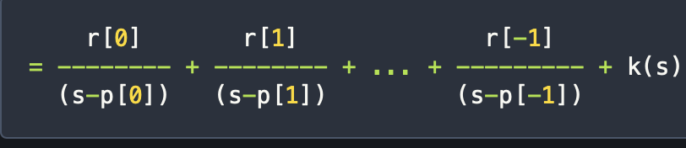My steps

Now following the linearity principle.

And as the system is causal as well, the total description should be able to be written as:

=================================  
   
or

=================================

## Opgave 4. Discrete time LTI system with impulse response.

### Consider a discrete time LTI system with the impulse response and inputs signal…



1. Sketch the signals h[n] and x[n]



1. Sketch the output signal for the input .

A trick is to transpose and calculating the sum alongside the right diagonal.



Making sure with numpy.convole:

Which is the exact same that I got.

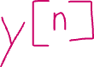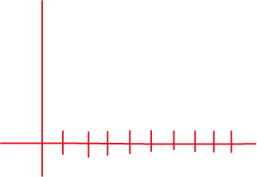

### Consider a CTLTI system with the impulse response

The following input signal is considered:

1. Sketch the signals and

So same procedure as the discrete time but a little different. For this first sketch it won’t make a difference.

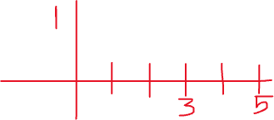

1. Sketch the output signal for the input

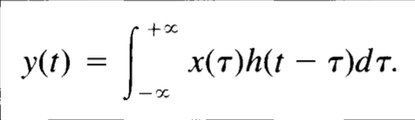Now instead of the convolution sum in discrete, we now need to do the convolution integral.

Just with discrete, the response has been reversed, now in time.

Let me look at the regions for convolution.

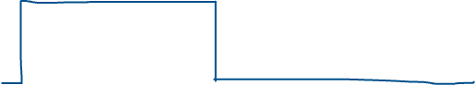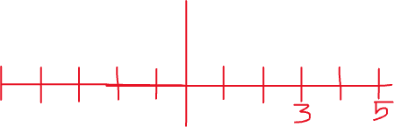

Area underneath is:

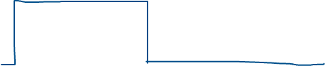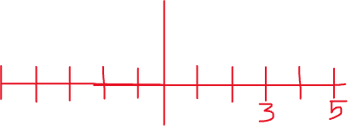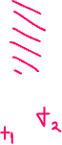

Area underneath is:

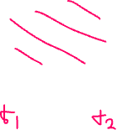

Area underneath is:

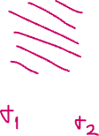

And the rest is 0.

Now I can describe

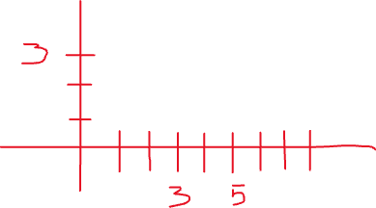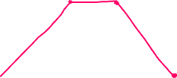

## Opgave 5

### A continuous-time causal LTI system is characterized by the differential equation,

where x(t) represents the input signal and y(t) represents the output signal.

1. Find H(s)

I use laplace transformation on the system and assumes, that the system is causal and thus at rest at start. With that I will have no initial slope, nor any initial accelerations.

And the same for X.

=================  
   
=================

1. Specify the region of convergence ROC, poles and zeros of H(s) on a plot.

I could do this multiple ways. For simplicity the partial fraction would probably be the easiest approach

I will use scipy to do the partial fraction.

And if the system is linear, as I suspect, then I have a ROC at . The common regions for the two regions of convergence.

And for linearity, the functions can be written as

And so, I have

Thus the convergence occurs, when the real part of s is larger than 4.   
  
For poles and zeros, I will be using scipy to find those.   
And I get.





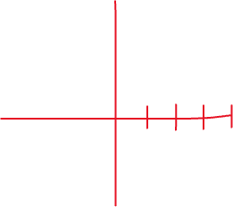

### Sketch the corresponding region of convergence in each pole zero plot below, considering the statements about x(t).

1. x(t) is absolutely integral.

1. x(t) = 0, t < -2

1. x(t)e^3t is absolutely integrable. ( Hint property of shifting in s-domain. )

Script for brute forcing of coefficients and plotting:

Plot for Plot for

Plot for plot for

Okay I see them converging against a different signal than for what I solved for. Maybe it has to do with the fact, that I’m only taking the positive k’s, thus not making it symmetrical.   
For k = 0 I need to do something, as this is a singularity.

As the a0 acts as a dc value, the average part, I can just make sure that I don’t calculate for this, at instead insert the dc value.   
For the signal I had a triangle, and a square.

And the average is then the area divided by the period.

Final plot

I didn’t want to converge to the signal I wanted. Maybe I am missing something.

I used chat and it still used k only for the positive values.   
Now trying this again with   
nt = 1000  
nk = 96

It seems like it converges into this one.

Mirroring it kinda makes it look like the orignal, but with a slope instead of the discontinuity   
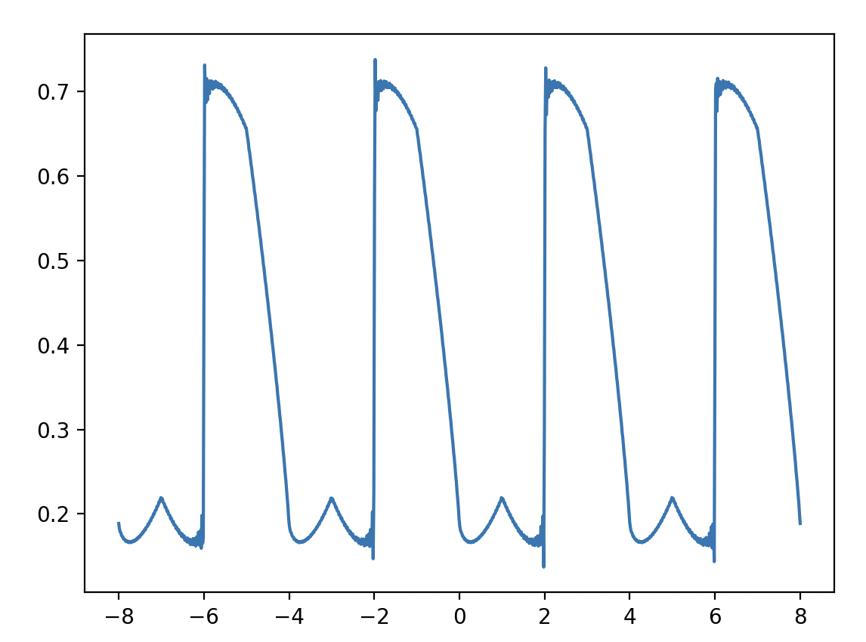



My most energy required plot:

## Opgave 3

## Opgave 4